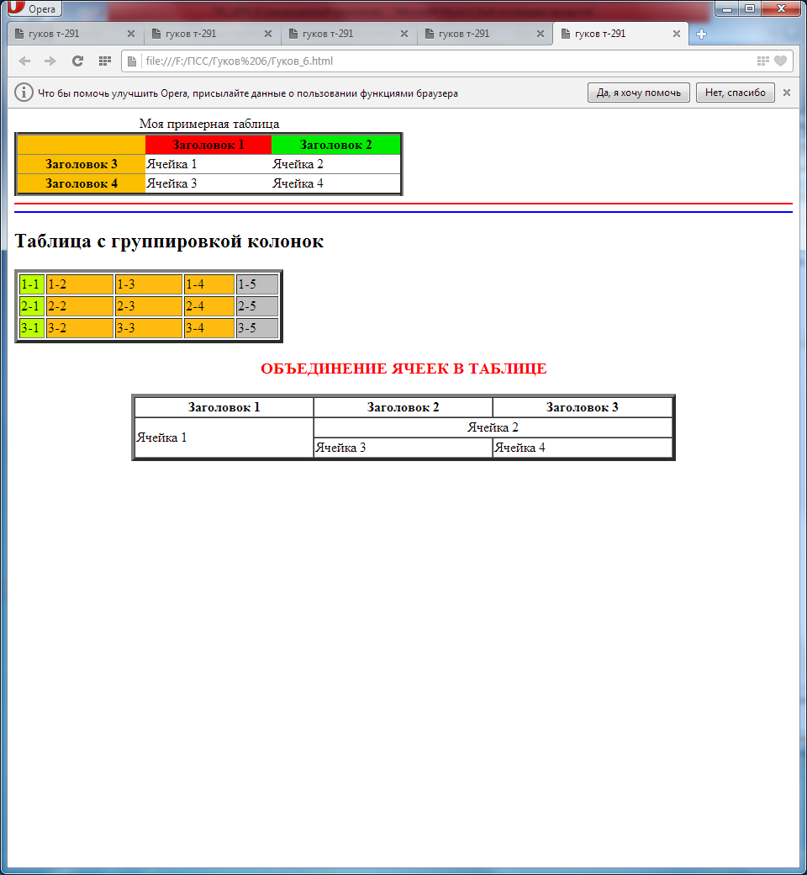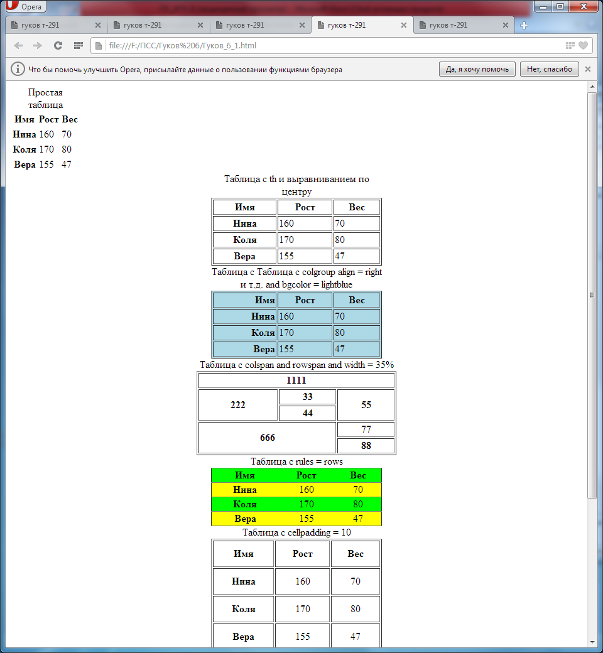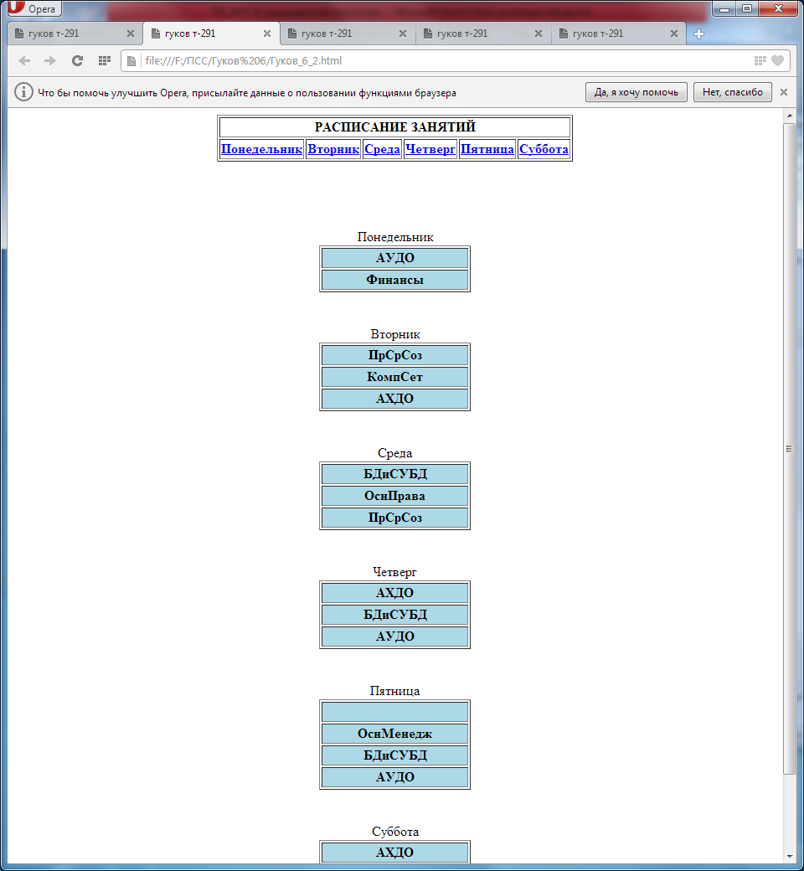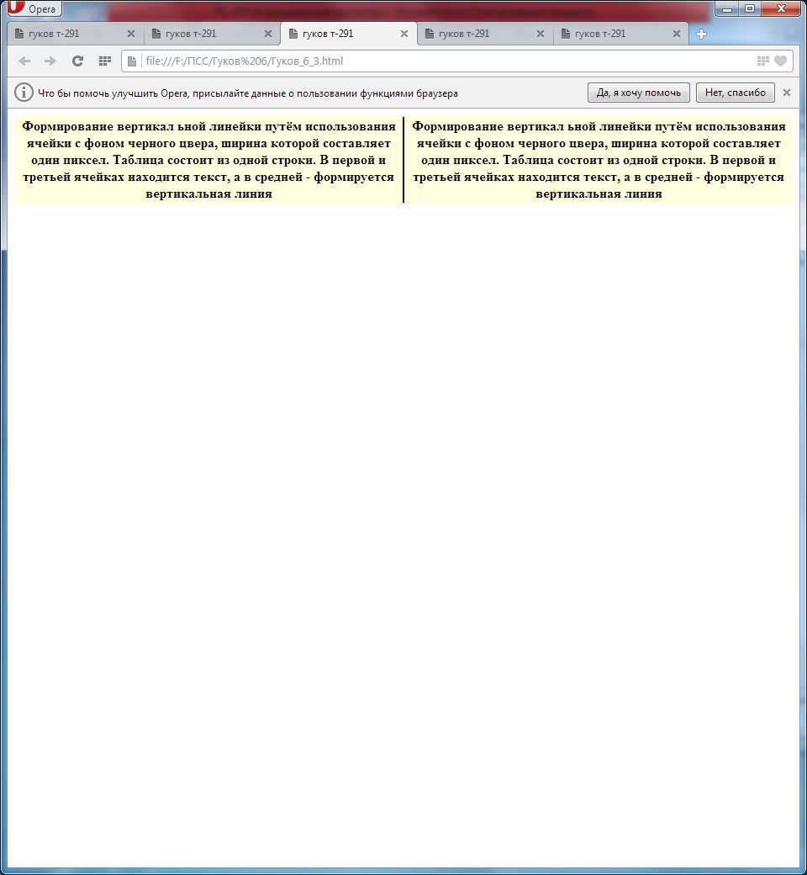

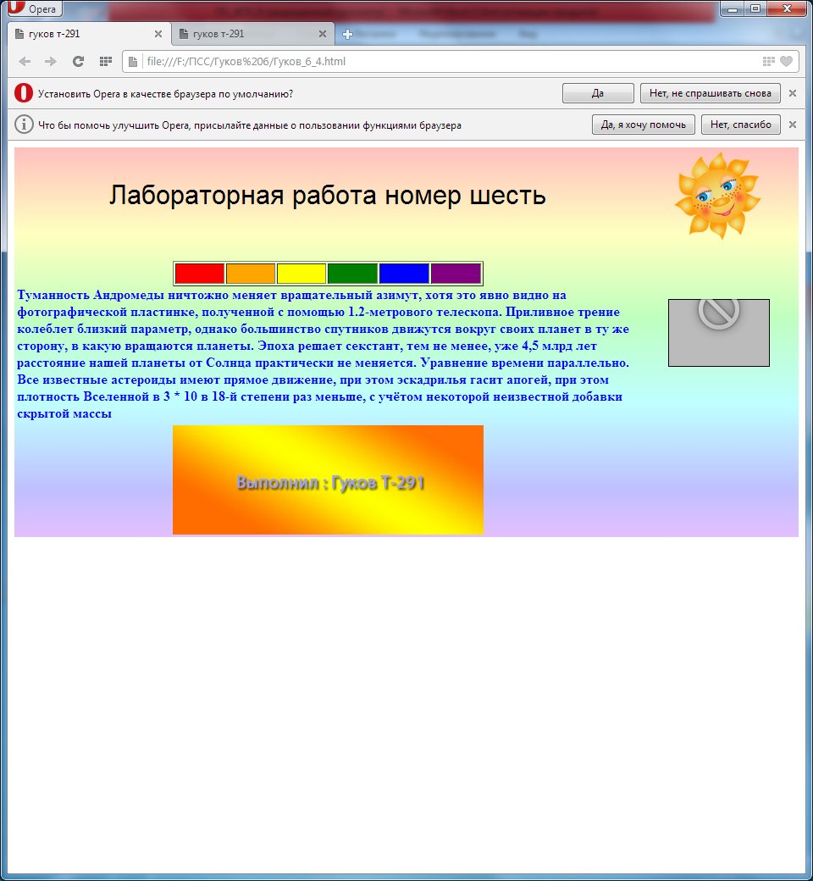

1. <table></table>; <tr></tr>,<th></th>,<td></td>,<caption>
2. Align, border, width, rules, cellspacing
3. <caption align = top, bottom, left, right>
4. <tr></tr>
5. <td></td>